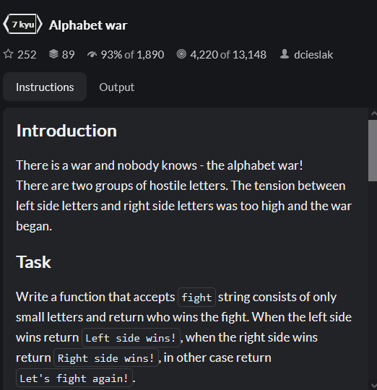

* Create a mapping of the letters and values, assign negatives to one group,
* Split input string into letters, map them into numbers, remove all non matches,
* Sum up all the values,
* Finally, compare and output relevant string

Other solutions:

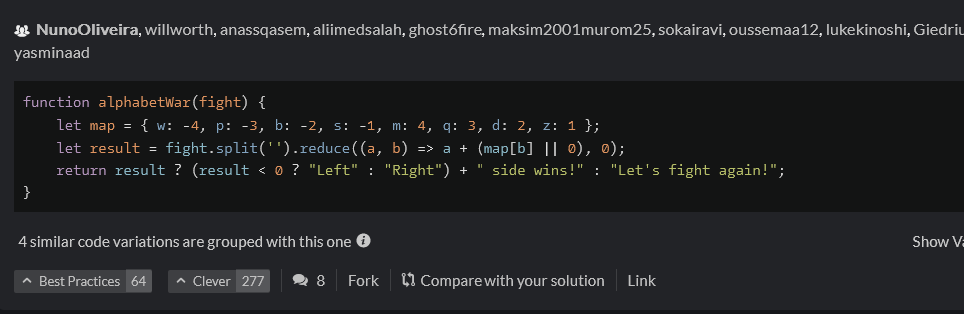

* Highly similar, just no map or filter function.
* Instead uses expression directly in reduce function to sum up the values.

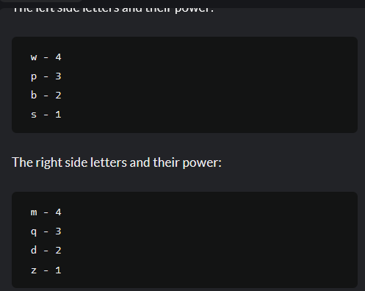

* Need to store letters as an array, done using split method,
* Need a copy of this array to mutate,
* Loop over array,
* Check if element is equal to *,
* If it is, then change element, the one before and after to _,
* Make sure to accommodate for first and last edge cases,
* We can have an array of letters that are either left letters, right letters, neither, or underscores,
* Create a map for the scoring,
* Use reduce to generate a value from the scores,
* Conditionally check for the result

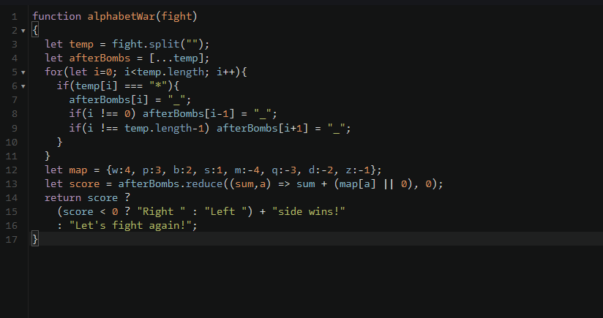

Other solutions:

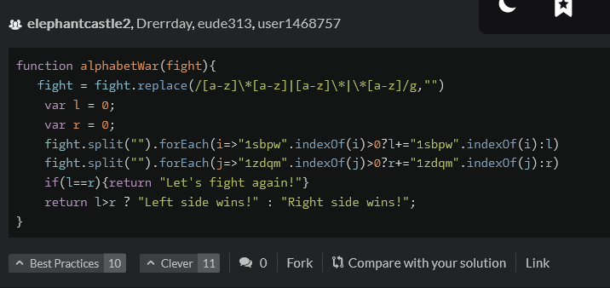

* A regex used to replace the follows combos: letter*letter, *letter, letter*, with empty spaces,
* Scoring then calculated individual for left and right sides,
* Compared together for outputs.

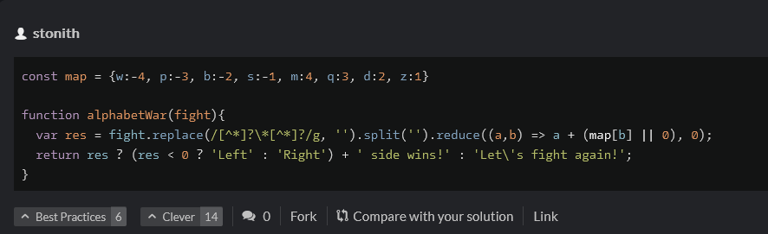

* Shorter solution that essentially does the same things,
* Regex replacement done, then reduce method applied with map immediately,
* Finally, comparison done to output result.